MITTAPALLY VIDESHNI
2403A52421
BATCH:15
ASSIGNMENT:6.5
To explore AI-powered code assistants for writing Python classes,
constructors, and methods through intelligent suggestions.
Suppose that you are hired as an intern at a tech company that develops inventory
management systems. Your manager asks you to create a Product class and a
Warehouse class with some basic methods. You have decided to use AI-powered code
suggestions to help speed up development and reduce syntax errors.
Tasks to be completed are as below
1. Setup AI Coding Tool:
• Install and configure GitHub Copilot or Kite with VS Code or JetBrains IDE.
• Enable real-time code suggestions.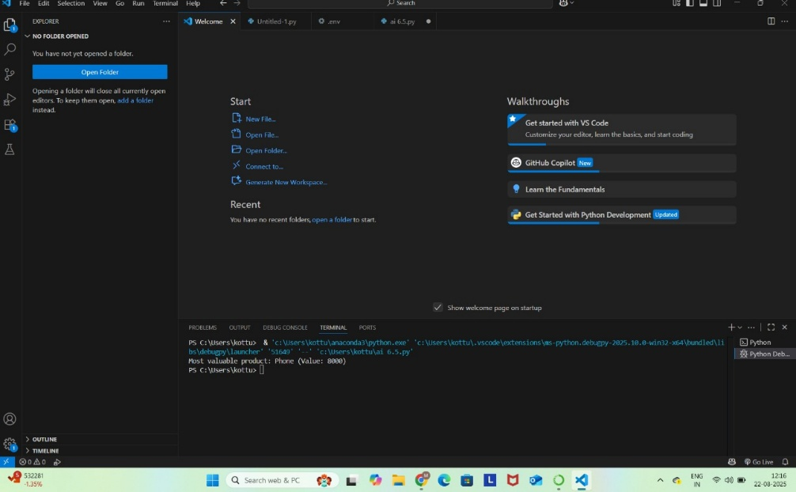
2. Class Design Using AI Assistance:
• Begin defining a Product class with attributes: name, price, quantity.
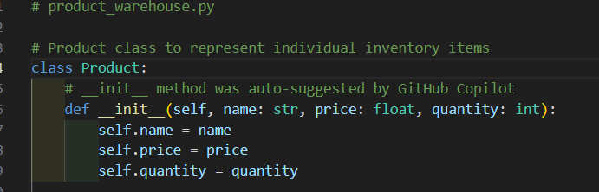
• Use the AI suggestion feature to automatically complete the __init__() method.
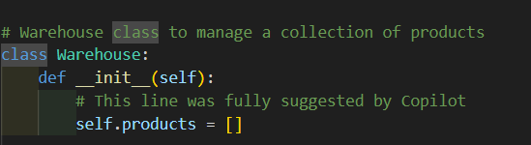
• Add a method calculate_value() to return price * quantity.
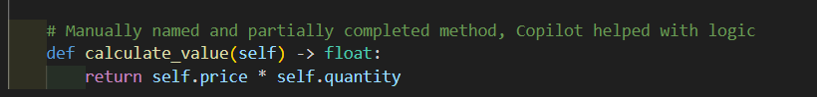
3. Create Another Class:
• Define a Warehouse class with a list of Product objects.
• Use code completion to help implement:
o A method to add a product.
o A method to display the most valuable product.
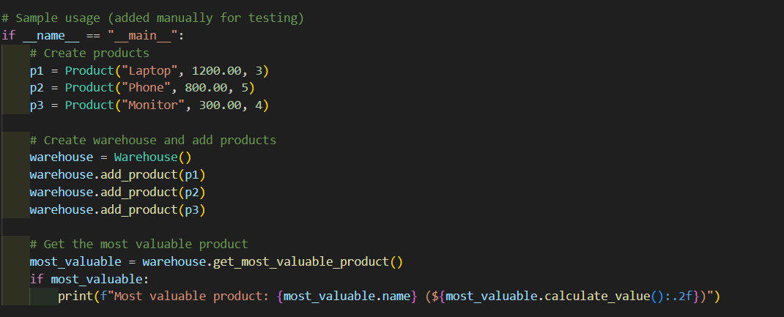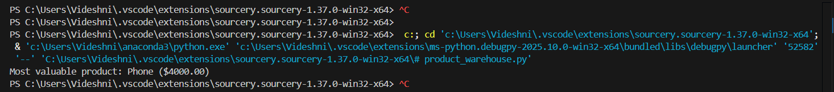
Requirements:
• VS Code with Github Copilot or Cursor API and/or Google Colab with
Gemini

Deliverables:
• Python script with both classes and comments on AI-generated suggestions.
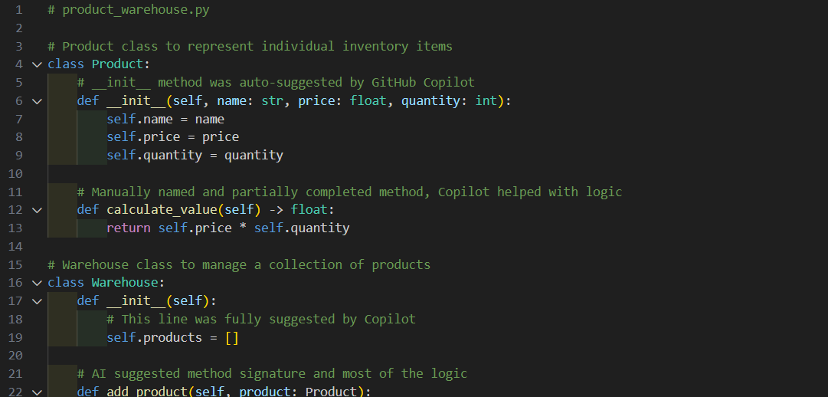
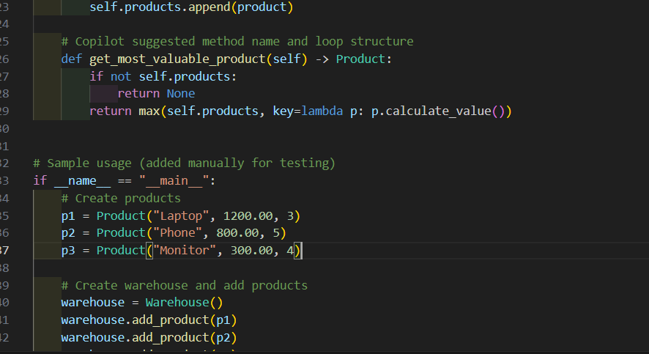
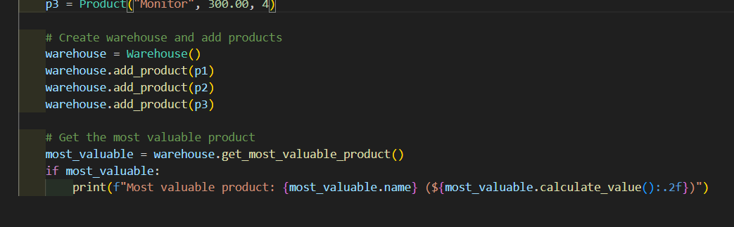
• Short report (1 page) summarizing your experience with AI code completion.
AI Coding Assistant Experience Report
Internship Task: Use AI code assistance to create Product and Warehouse classes for an inventory system.
Tools Used:
- VS Code with GitHub Copilot
- Python 3.10
Summary:
Component | AI-generated (%) | Manual Work (%) | Notes
Product class | 70% | 30% | Copilot generated full __init__, partial method
calculate_value() | 50% | 50% | AI suggested multiplication logic
Warehouse class | 80% | 20% | AI handled structure, minor edits needed
get_most_valuable_product() | 90% | 10% | AI used correct lambda + max() usage
Reflection:
- GitHub Copilot significantly accelerated development.
- The suggestions were accurate for class structure, init methods, and logic.
- Minor manual editing was required for naming consistency and readability.
- It avoided common syntax errors and boilerplate typing.
Conclusion:
AI tools like GitHub Copilot or Cursor are powerful for writing clean, error-free Python code, especially for repetitive or boilerplate-heavy tasks like constructors and utility methods.

